**Description:**

This project was created as a layout for the management of a coffee shop. It includes 7 screens that are home, menu, location/delivery, contact, login, cart/bill screens and every screen contains a navigation bar through which the user can access all these screens. The home page will contain two buttons more on menu and location button the more on menu button will open up the menu screen and the location button will open up the location/ delivery screen, the contact screen contains an email address for feedback and further contact information, the login screen contains a username and password for the user to get login, the cart/bill screen contains a list of items that the user added in his cart and quantity of that items and will display a bill receipt that contains the number of items the user have bought with the total amount.

**Features:**

* It has a main home page where shortcuts of your favorite item like coffee, starter are available.
* It has a simple menu setup which will show you foods and drinks of different categories with prices.
* It has a location/delivery areas corner where information about our cafes branches are available like address, contacts and list of delivery areas that means in which area our home delivery service is available.
* It has a login form where a user can login with him/her username and password.
* It has a cart and billing corner. In cart it has show user the things which he added in it to buy and billing area has show user the receipt/bill in which how many items the user have bought with their names and quantity and price will display with the total amount.
* It has a contact page where our email address our social app pages information are available.

**CODING:**

**Linking:**

private void jButton1ActionPerformed(java.awt.event.ActionEvent evt) {

Home h=new Home();

h.setVisible(true);

this.setVisible(false);

}

private void jButton3ActionPerformed(java.awt.event.ActionEvent evt) {

Location_Delivery LD=new Location_Delivery();

LD.setVisible(true);

this.setVisible(false);

}

private void jButton4ActionPerformed(java.awt.event.ActionEvent evt) {

Log_in Li=new Log_in();

Li.setVisible(true);

this.setVisible(false);

}

private void jButton5ActionPerformed(java.awt.event.ActionEvent evt) {

Contact c=new Contact();

c.setVisible(true);

this.setVisible(false);

}

private void jButton7ActionPerformed(java.awt.event.ActionEvent evt) {

Menu m=new Menu();

m.setVisible(true);

this.setVisible(false);

}

private void jButton8ActionPerformed(java.awt.event.ActionEvent evt) {

Location_Delivery LD=new Location_Delivery();

LD.setVisible(true);

this.setVisible(false);

}

private void jButton9ActionPerformed(java.awt.event.ActionEvent evt) {

Menu m=new Menu();

m.setVisible(true);

this.setVisible(false);

}

**Cart:**

private void jButton2ActionPerformed(java.awt.event.ActionEvent evt) {

// TODO add your handling code here:

BeveragesCart bgc=new BeveragesCart();

bgc.setVisible(true);

bgc.jBvgTextArea.setFont(new java.awt.Font("Rockwell", 1, 18));

bgc.jBvgTextArea.append("\t\tBreverages Cart");

bgc.jBvgTextArea.append("\n______________________________________________________________________");

bgc.jBvgTextArea.append("\nProduct\t\tQuantity\tPrice");

bgc.jBvgTextArea.append("\n_______________________________________________________________________\n\n");

if(nutellashakequant>0){

bgc.jBvgTextArea.setFont(new java.awt.Font("Rockwell", 0, 14));

bgc.jBvgTextArea.append(getnutellashake+"\t\t"+nutellashakequant);

bgc.jBvgTextArea.append("\t"+nutellashakebill+"\n");

}

if(espressoiceslashquant>0){

bgc.jBvgTextArea.setFont(new java.awt.Font("Rockwell", 0, 14));

bgc.jBvgTextArea.append(getespressoiceslash+"\t"+espressoiceslashquant);

bgc.jBvgTextArea.append("\t"+espressoiceslashbill+"\n");

}

if(gelatoshakequant>0){

bgc.jBvgTextArea.setFont(new java.awt.Font("Rockwell", 0, 14));

bgc.jBvgTextArea.append(getgelatoshake+"\t\t"+gelatoshakequant);

bgc.jBvgTextArea.append("\t"+gelatoshakebill+"\n");

}

if(hotchocolatequant>0){

bgc.jBvgTextArea.setFont(new java.awt.Font("Rockwell", 0, 14));

bgc.jBvgTextArea.append(gethotchocolate+"\t\t"+hotchocolatequant);

bgc.jBvgTextArea.append("\t"+hotchocolatebill+"\n");

}

if(freshlimequant>0){

bgc.jBvgTextArea.setFont(new java.awt.Font("Rockwell", 0, 14));

bgc.jBvgTextArea.append(getfreshlime+"\t\t"+freshlimequant);

bgc.jBvgTextArea.append("\t"+freshlimebill+"\n");

}

if(espressosmoothiequant>0){

bgc.jBvgTextArea.setFont(new java.awt.Font("Rockwell", 0, 14));

bgc.jBvgTextArea.append(getespressosmoothie+"\t\t"+espressosmoothiequant);

bgc.jBvgTextArea.append("\t"+espressosmoothiebill+"\n");

}

totalprice=nutellashakebill+espressoiceslashbill+gelatoshakebill+hotchocolatebill+freshlimebill+espressosmoothiebill;

bgc.jBvgTextArea.append("\n_______________________________________________________\n");

bgc.jBvgTextArea.setFont(new java.awt.Font("Rockwell", 1, 18));

bgc.jBvgTextArea.append("\n\t\t\tTotal "+totalprice);

}

**Bill:**

private void jButton7ActionPerformed(java.awt.event.ActionEvent evt) {

// TODO add your handling code here:

Bill b=new Bill();

b.setVisible(true);

b.jBillTextArea.setFont(new java.awt.Font("Rockwell", 1, 18));

b.jBillTextArea.append("\t\tBeverages Receipt");

b.jBillTextArea.append("\n_______________________________________________________________________");

b.jBillTextArea.append("\nProduct\t\tQuantity\tPrice");

b.jBillTextArea.append("\n_______________________________________________________________________\n\n");

if(nutellashakequant>0){

b.jBillTextArea.setFont(new java.awt.Font("Rockwell", 0, 14));

b.jBillTextArea.append(getnutellashake+"\t\t"+nutellashakequant);

b.jBillTextArea.append("\t"+nutellashakebill+"\n");

}

if(espressoiceslashquant>0){

b.jBillTextArea.setFont(new java.awt.Font("Rockwell", 0, 14));

b.jBillTextArea.append(getespressoiceslash+"\t"+espressoiceslashquant);

b.jBillTextArea.append("\t"+espressoiceslashbill+"\n");

}

if(gelatoshakequant>0){

b.jBillTextArea.setFont(new java.awt.Font("Rockwell", 0, 14));

b.jBillTextArea.append(getgelatoshake+"\t\t"+gelatoshakequant);

b.jBillTextArea.append("\t"+gelatoshakebill+"\n");

}

if(hotchocolatequant>0){

b.jBillTextArea.setFont(new java.awt.Font("Rockwell", 0, 14));

b.jBillTextArea.append(gethotchocolate+"\t\t"+hotchocolatequant);

b.jBillTextArea.append("\t"+hotchocolatebill+"\n");

}

if(freshlimequant>0){

b.jBillTextArea.setFont(new java.awt.Font("Rockwell", 0, 14));

b.jBillTextArea.append(getfreshlime+"\t\t"+freshlimequant);

b.jBillTextArea.append("\t"+freshlimebill+"\n");

}

if(espressosmoothiequant>0){

b.jBillTextArea.setFont(new java.awt.Font("Rockwell", 0, 14));

b.jBillTextArea.append(getespressosmoothie+"\t\t"+espressosmoothiequant);

b.jBillTextArea.append("\t"+espressosmoothiebill+"\n");

}

b.jBillTextArea.append("\n________________________________________________________________________\n");

double totalprice=nutellashakebill+espressoiceslashbill+gelatoshakebill+hotchocolatebill+freshlimebill+espressosmoothiebill;

b.jBillTextArea.setFont(new java.awt.Font("Rockwell", 1, 18));

b.jBillTextArea.append("\n\t\t\tTotal "+totalprice);

}

**SCREEN SHOTS:**

**Home:**

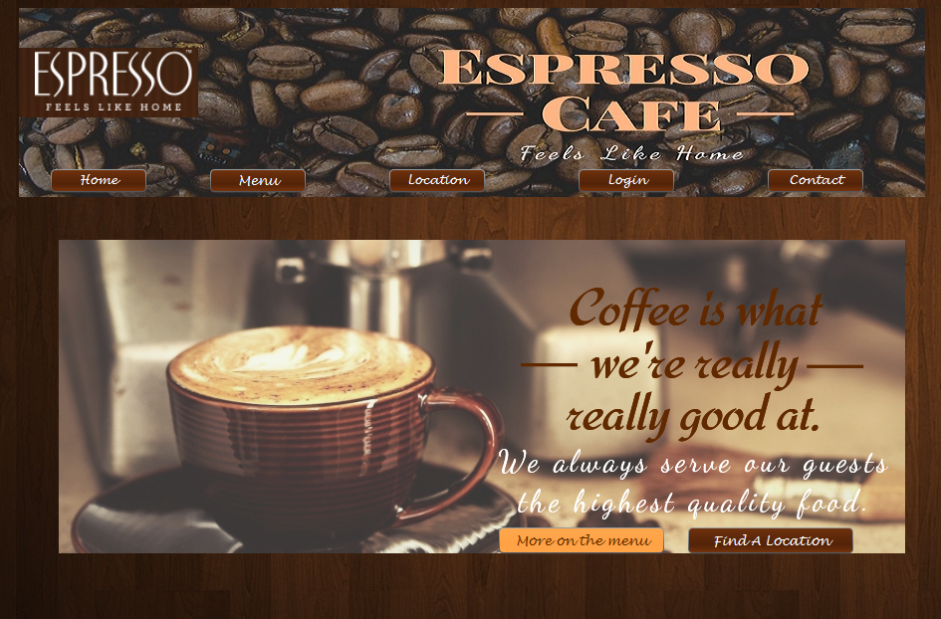

**Menu:**

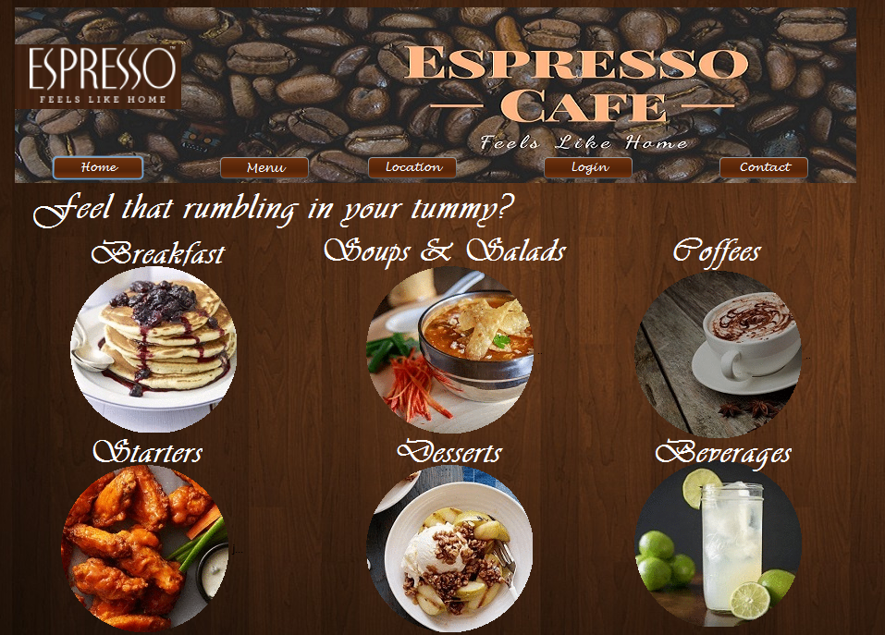

**Beverages:**

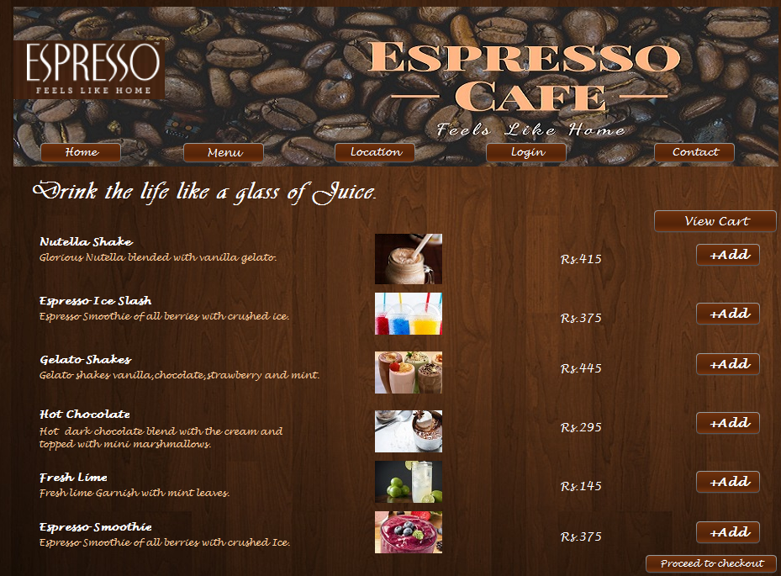

**Location:**

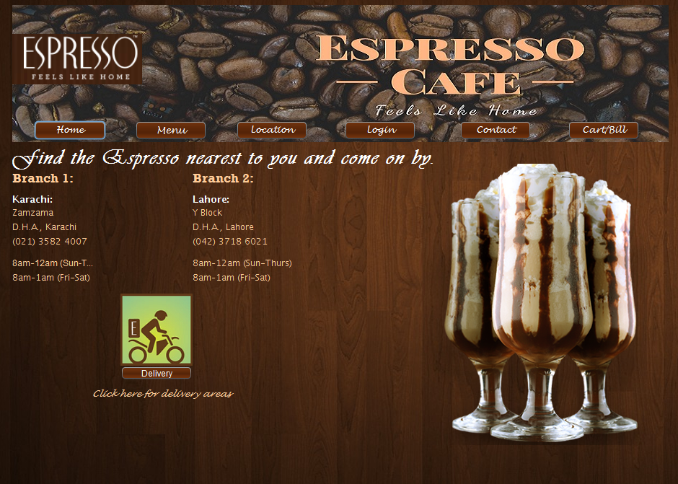

**Delivery:**

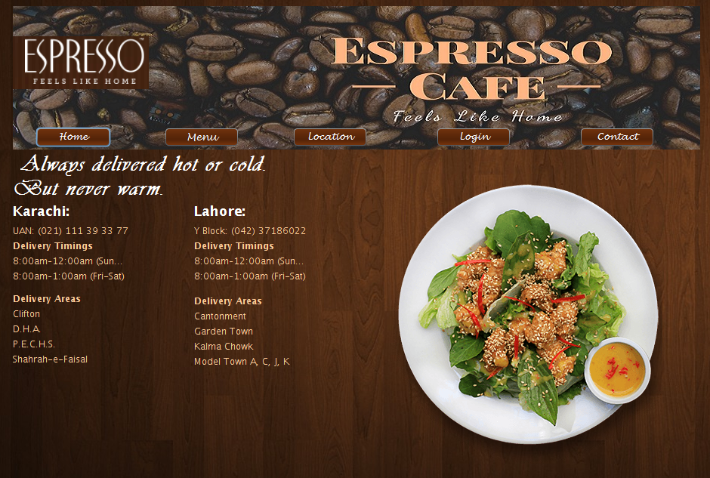

**Contact:**

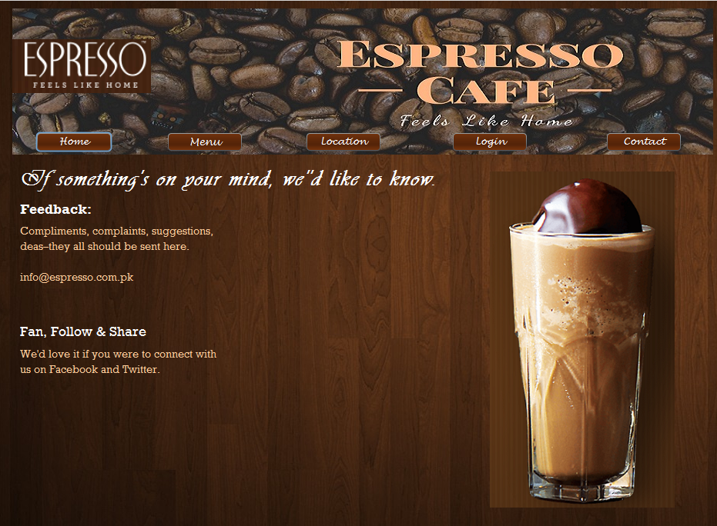

**Cart:**

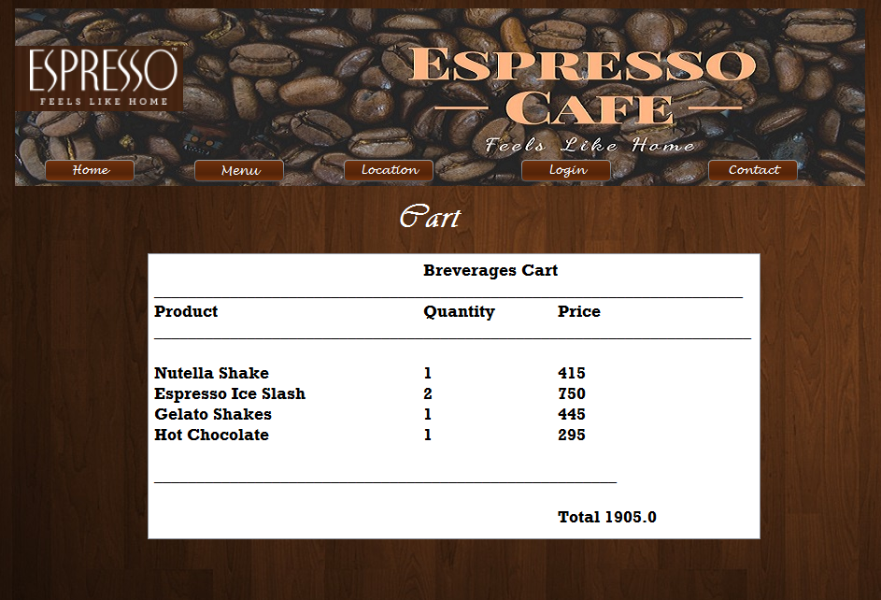

**Bill:**

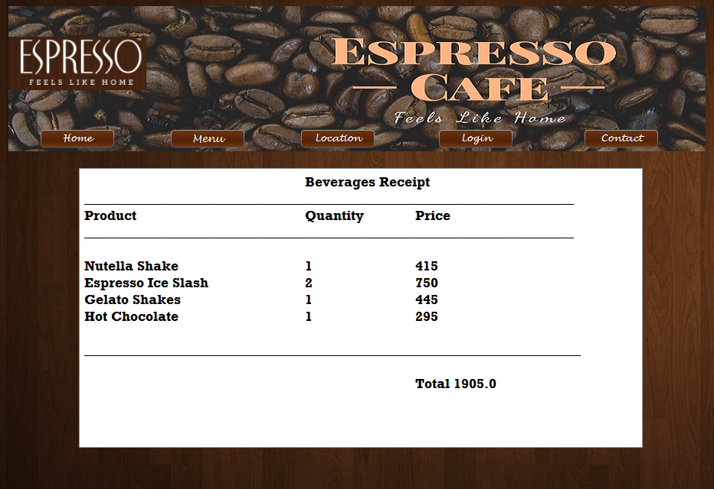

**Login:**

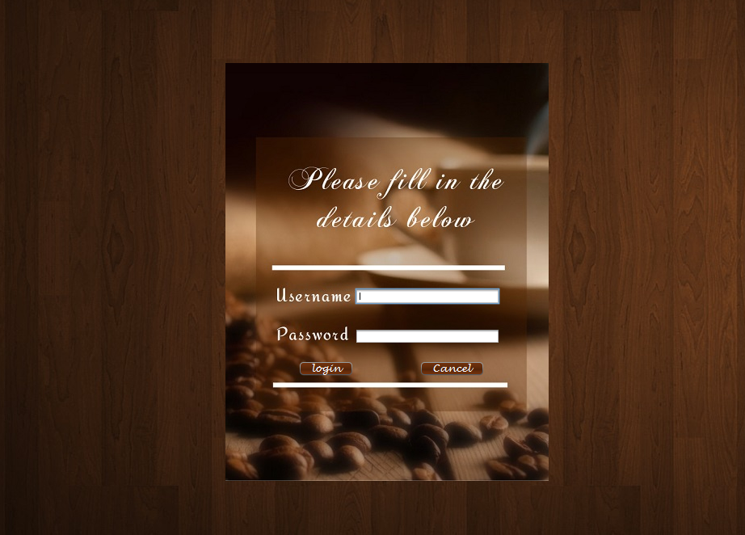

**CONCLUSION:**

In this project, we obtained more experience with designing a code using Net beans IDE.

And it is also show us the problem that can occur in designing and taught us how to overcome it, basically this project help us to increase our knowledge and make us understand how to implement design in new and better way .